**NAN MUDHALVAN PROJECT**

**BLOCKCHAIN ELECTRONIC VOTING SYSTEM**

**TEAM NM ID – NM2023TMID07609**

**S-ARAVIND RAJ**

**PN-MOHAMMED ZAID JUBRAN**

**N-MAGESH**

**M-BALAJI**

**TABLE OF CONTENT**

**1. INTRODUCTION**

**1.1 Project Overview**

**1.2 Purpose**

**2. LITERATURE SURVEY**

**2.1 Existing problem**

**2.2 References**

**2.3 Problem Statement Definition**

**3. IDEATION & PROPOSED SOLUTION**

**3.1 Empathy Map Canvas**

**3.2 Ideation & Brainstorming**

**4.REQUIREMENT ANALYSIS**

**4.1 Functional requirement**

**4.2 Non-Functional requirements**

**5. PROJECT DESIGN**

**5.1 Data Flow Diagrams & User Stories**

**5.2 Solution Architecture**

**6. PROJECT PLANNING & SCHEDULING**

**6.1 Technical Architecture**

**6.2 Sprint Planning & Estimation**

**6.3 Sprint Delivery Schedule**

**7. CODING & SOLUTIONING (Explain the features added in the project along with code)**

**7.1 Feature 1**

**7.2 Feature 2**

**7.3 Database Schema (if Applicable)**

**8. PERFORMANCE TESTING**

**8.1 Performance Metrics**

**9. RESULTS**

**9.1 Output Screenshots**

**10. ADVANTAGES & DISADVANTAGES**

**11. CONCLUSION**

**12. FUTURE SCOPE**

**13. APPENDIX**

**Source Code**

**GitHub & Project Demo Link**

**1.INTRODUCTION**

The introduction section of the document for the Electronic Voting System project serves as the gateway, providing essential context and an overarching view of the project. Let's delve deeper into the various components of this section:

**1.1 Project Overview:**

In the project overview, you present a concise yet comprehensive description of what the Electronic Voting System project entails. This is where you set the stage for readers to understand the project's core essence. Elaboration might include:

Project Name and Scope: You would explicitly mention the name of the project, which, in this case, is the "Electronic Voting System." It's vital to outline the boundaries and scope of the project, ensuring that readers understand what it encompasses.

Objectives: You can elaborate on the primary goals and objectives of the project. Mention what the project aims to achieve, such as enhancing the integrity of the voting process or improving accessibility for voters.

Target Audience: Clarify who the project is intended for. This could be government bodies, voters, election officials, or any other relevant stakeholders.

Significance: Explain why this project is important. Detail the problems or challenges the existing voting systems face and why the proposed solution is needed. You could talk about issues like fraud, security concerns, and transparency.

**1.2 Purpose:**

This section focuses on the purpose of the document itself. Here's an elaboration of this part:

**Document Clarification:** Clearly state that the purpose of this document is to provide an in-depth understanding of the Electronic Voting System project. It's intended to be a guide that helps stakeholders navigate through the project's planning, development, and execution.

**Stakeholder Guidance**: Explain that this document is designed to serve as a reference for various stakeholders, including project managers, developers, testers, and decision-makers. It helps them comprehend the project's background, objectives, and methodologies.

**Transparency and Clarity**: Emphasize the importance of transparency and clarity in project documentation. The purpose here is to ensure that anyone reviewing this document can gain a comprehensive insight into the project's foundations and execution plan.

By elaborating on these components in the introduction section, you set a strong foundation for the document, making it accessible and informative for all parties involved or interested in the Electronic Voting System project. This section's content serves as a guiding framework, facilitating a smoother understanding of the project's progression.

**2.LITERATURE SURVEY**

The Literature Survey section of the document for the Electronic Voting System project is a critical step in any research or development project. It involves an in-depth review of existing literature, research, and relevant sources to gain a comprehensive understanding of the problem domain and existing solutions. Here's a more detailed look at this section:

**2.1 Existing Problem:**

In this part, you will elaborate on the existing issues and challenges related to electronic voting systems. This section is essential to provide a context for why your project is necessary and how it aims to address specific problems. The elaboration could include:

Identification of Problems: Discuss various issues in current electronic voting systems, such as vulnerabilities, fraud, lack of transparency, and accessibility problems. Explain the impact of these problems on the electoral process and the need for a better solution.

**Case Studies**: If available, you can include real-world examples or case studies that highlight instances where electronic voting systems have failed or faced security breaches. This adds concrete evidence to the issues at hand.

Comparison to Traditional Voting: Highlight the differences and challenges that electronic voting systems face compared to traditional paper-based voting systems. This comparison can emphasize the need for a more robust solution.

**2.2 References:**

In this part, you'll list the references and sources you've consulted during the project's planning and research phase. Elaboration here could involve:

Citation of Sources: Clearly cite and reference the books, academic papers, reports, articles, and any other materials that you've reviewed. It's important to adhere to a specific citation style, such as APA, MLA, or Chicago, as required.

Diverse Sources: Mention the variety of sources you've consulted to ensure the credibility and reliability of your research. These sources might include academic journals, government reports, and expert publications.

Relevance to the Problem: Explain how each reference is relevant to the issues and challenges identified in the previous section. This helps readers understand why these sources were consulted.

**2.3 Problem Statement Definition:**

This part involves elaborating on the problem statement, which is crucial for clarifying the specific problem your project seeks to address. Here's how to elaborate on this:

**Precise Problem Statement:** Provide a clear, concise, and well-defined problem statement that encapsulates the core issue you aim to resolve with the Electronic Voting System project. Be specific about the problem's scope and impact.

**Root Causes:** Discuss the root causes of the problem, exploring why these issues persist in existing electronic voting systems. Understanding the underlying factors is essential for designing an effective solution.

**Connection to the Project:** Explain how the identified problem directly relates to the objectives of your project. Show that your project is well-aligned with addressing the challenges you've identified.

By elaborating on the existing problems, citing relevant references, and defining the problem statement with clarity, the Literature Survey section sets the foundation for the project's solution. It provides a strong rationale for the development of the Electronic Voting System and establishes the context in which your project operates.

**3.IDEATION & PROPOSED SOLUTION**

The Ideation & Proposed Solution section of the document for the Electronic Voting System project is a pivotal phase where the creative process of generating ideas and concepts meets the concrete proposal for a solution. Let's delve deeper into the various components of this section:

**3.1 Empathy Map Canvas:**

The Empathy Map Canvas is a tool for understanding the needs, behaviors, and emotions of the users or stakeholders involved in the Electronic Voting System project. Here's how to elaborate on this part:

User Persona Creation: Begin by creating detailed user personas, representing various categories of users, including voters, election officials, and administrators. Describe their characteristics, motivations, and pain points.

Mapping Needs and Emotions: For each user persona, use the Empathy Map Canvas to map their needs, desires, fears, and frustrations. This helps create a deep understanding of what users expect from the voting system and what problems they currently face.

Identifying Opportunities: Use the information gathered from the empathy maps to identify opportunities for improvement. Consider how the proposed solution can address the needs and emotions of different user groups.

**3.2 Ideation & Brainstorming:**

This section focuses on the creative process that led to the proposed solution for the Electronic Voting System. Elaboration here could include:

**Brainstorming Sessions:** Describe the brainstorming sessions where project team members, stakeholders, or experts generated ideas and concepts for improving the electronic voting system. Highlight the diversity of ideas and perspectives considered.

**Idea Generation:** Explain the specific ideas and concepts that emerged during these brainstorming sessions. You can elaborate on the key features, innovations, or technologies that were proposed as potential solutions.

**Selection of the Proposed Solution**: Discuss the criteria used to select the final proposed solution from the generated ideas. Explain why the chosen solution aligns with the project's objectives and the problems identified in the literature survey.

**Innovation and Creativity**: Highlight the innovative aspects of the proposed solution. Explain how it breaks new ground or offers a unique approach to addressing the challenges in electronic voting systems.

By elaborating on the empathy map canvas and the ideation and brainstorming process, this section provides insights into the human-centered approach of the project and the creative thinking that went into developing the proposed solution. It sets the stage for the reader to understand the genesis of the project's solution and its potential to address the identified problems effectively.

**4.REQUIREMENT ANALYSIS**

The Requirement Analysis section of the document for the Electronic Voting System project is a crucial step that defines the essential functional and non-functional aspects of the system. Let's delve deeper into the various components of this section:

**4.1 Functional Requirement:**

This section outlines the functionalities and features that the Electronic Voting System must possess. Elaboration here could include:

Detailed Feature List: Provide a comprehensive list of features that the electronic voting system should offer. This could include functions such as user registration, vote casting, vote counting, result display, and administrative tools.

**User Stories:** Present user stories that describe how different types of users will interact with the system. These stories help in understanding the system from a user's perspective, such as "As a voter, I want to be able to cast my vote securely."

**Use Cases:** Elaborate on specific use cases or scenarios that the system needs to support. For example, you can detail the steps involved in a voter's journey from registration to casting a vote.

**Functional Requirements Matrix**: Create a matrix that links each requirement to its corresponding feature or use case. This helps in ensuring that all functional aspects are covered.

**4.2 Non-Functional Requirements:**

This part focuses on the non-functional aspects of the Electronic Voting System, which include performance, security, scalability, and other attributes. Elaboration here could include:

**Performance Requirements**: Define specific performance metrics that the system should meet. For example, you can specify the maximum response time for user interactions or the system's capacity to handle a certain number of simultaneous votes.

**Security Requirements:** Explain the security measures and standards that must be implemented to safeguard the voting process. This includes encryption, user authentication, and protection against cyber threats.

**Scalability Requirements**: Describe how the system should scale to accommodate an increasing number of voters. This can involve details about load balancing, server capacity, and data storage.

**Usability and Accessibility**: Specify user interface design principles, making the system user-friendly and accessible for all users, including those with disabilities.

**Regulatory Compliance:** If applicable, mention any legal or regulatory requirements that the system must adhere to, such as data privacy regulations or election laws.

**Reliability and Availability**: Detail how the system will ensure high reliability and availability during election periods. This includes backup and failover mechanisms.

By elaborating on both functional and non-functional requirements, this section ensures that the Electronic Voting System's characteristics and capabilities are well-defined. It serves as a foundation for the subsequent stages of the project, such as design, development, and testing, helping to align the project with the specific needs and expectations of stakeholders.

**5.PROJECT DESIGN**

The Project Design section of the document for the Electronic Voting System project is a critical phase that lays the groundwork for how the system will be structured and how it will operate. It includes the development of visual representations and architectural plans. Here's an elaboration of the key components of this section:

**5.1 Data Flow Diagrams & User Stories:**

**Data Flow Diagrams (DFD):**

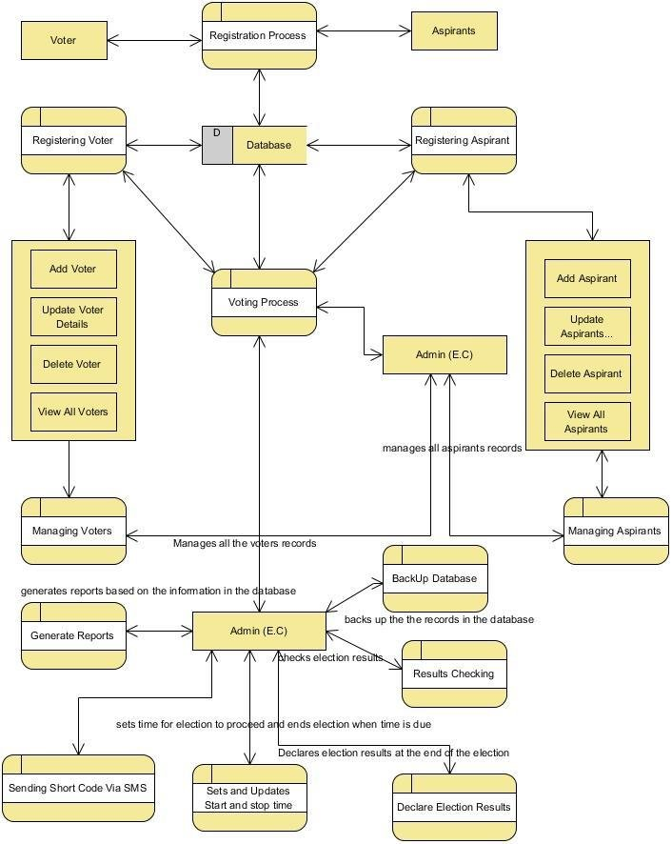

This section involves the creation of DFDs to visualize the flow of data within the Electronic Voting System. DFDs typically consist of processes, data stores, data flow, and external entities. Elaboration may include the following:

**Context Diagram:**

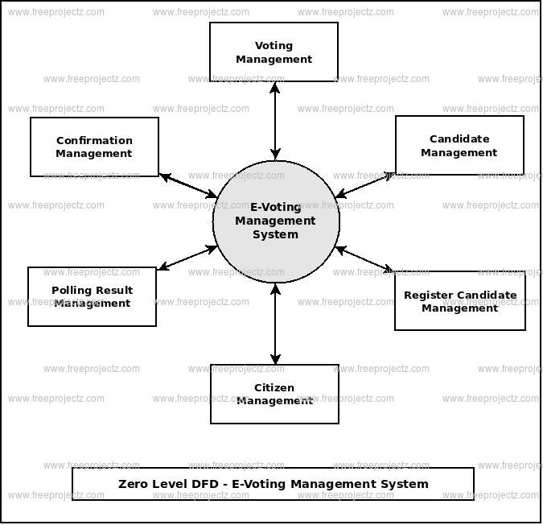

Begin with a context diagram that provides an overview of the system, illustrating the major external entities and their interactions with the system.

**Level 0 DFD:** Present a Level 0 DFD, which breaks down the system into high-level processes and shows how data moves between them.

**User Stories:** In this part, elaborate on the user stories created for the system. You can explain user stories from various perspectives, such as voters, election officials, and administrators. These stories help in understanding how users will interact with the system.

**UseCaseDiagram:**

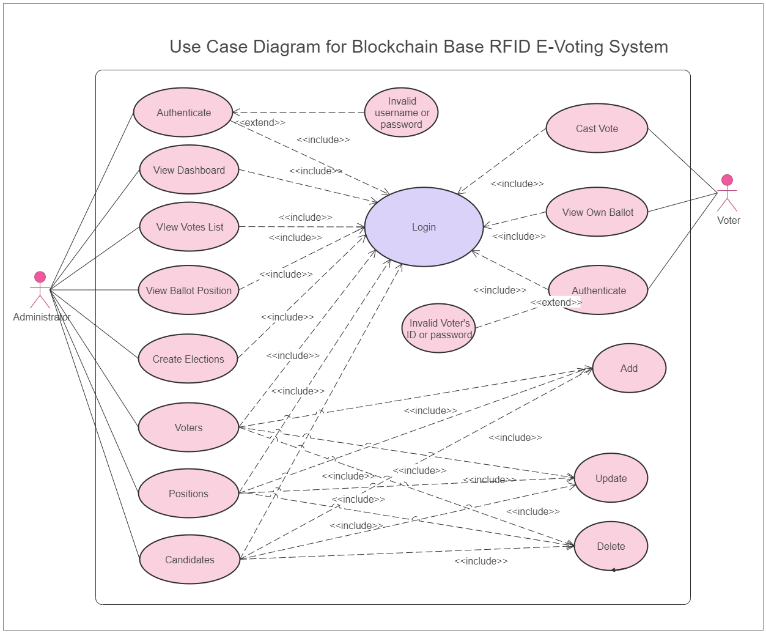

If applicable, create use case diagrams that provide a visual representation of the interactions between actors (users) and the system. Each use case should be detailed, explaining the steps involved.

**5.2 Solution Architecture:**

High-Level Architecture: Define the high-level architecture of the Electronic Voting System, which outlines the key components and their interactions. This could involve client-side and server-side architecture, including web servers, databases, and user interfaces.

Component Breakdown: Elaborate on the different components or modules that make up the system. This includes describing what each component does, its dependencies, and its role in the overall architecture.

Technology Stack: Specify the technologies and frameworks that will be used in the development of the system. For instance, you may choose to use a specific programming language, a particular database system, and any external APIs or libraries.

Security Architecture: Describe the security architecture that will be implemented to protect the voting system from vulnerabilities and attacks. This could involve details about encryption, authentication, and access controls.

Scalability Plan: Explain how the system is designed to scale, both vertically and horizontally, to accommodate a growing number of users and votes. Detail any load balancing strategies and redundancy measures.

User Interface Design: If applicable, provide insights into the user interface design, explaining how it aligns with the usability and accessibility requirements. You can include wireframes or mockups of the system's screens.

Data Storage Strategy: Elaborate on the data storage strategy, including the type of database used, data modeling, and data retrieval methods.

By elaborating on data flow diagrams, user stories, and solution architecture, this section offers a comprehensive view of how the Electronic Voting System is structured, how data flows through it, and how it interacts with users and external entities. It serves as a critical guide for system designers, developers, and project stakeholders, providing a visual and conceptual understanding of the project's architecture.

**6.PROJECT PLANNING & SCHEDULING**

The Project Planning & Scheduling section of the document for the Electronic Voting System project is a pivotal aspect that outlines how the project will be executed, the technical architecture, sprint planning, and the timeline for project delivery. Here's a more detailed look at the components of this section:

**6.1 Technical Architecture:**

System Infrastructure: This part of the technical architecture describes the underlying infrastructure needed for the Electronic Voting System. It includes details about servers, databases, networking, and any other essential hardware components.

Software Stack: Elaborate on the software stack, including the programming languages, frameworks, and tools that will be used to develop the system. This section helps define the technology foundation upon which the project will be built.

Security Framework: Explain the security measures and practices that will be integrated into the technical architecture to ensure the system's safety. This includes encryption protocols, authentication methods, and access control mechanisms.

Integration Points: Discuss how the Electronic Voting System will integrate with other systems, if applicable. For instance, if the system needs to interact with voter registration databases or identity verification services, outline the integration points.

**6.2 Sprint Planning & Estimation:**

Sprint Duration: Define the duration of each sprint in the project. Sprints are time-bound development cycles that break the project into manageable pieces. This part provides an estimate of how long each sprint will last.

Sprint Goals: Elaborate on the goals and objectives of each sprint. Specify what features, functionalities, or tasks will be accomplished during a given sprint.

Resource Allocation: Detail the allocation of resources to different sprints. This includes assigning developers, designers, testers, and other team members to specific sprints.

Work Breakdown Structure (WBS): Provide a work breakdown structure that outlines the tasks and subtasks for each sprint. This helps in understanding the specific work that needs to be done in each cycle.

**6.3 Sprint Delivery Schedule:**

Overall Project Timeline: This section presents the overall project timeline, indicating when each sprint will occur and when the project is expected to be completed. It provides stakeholders with a clear view of the project's progress.

Milestones: Highlight key milestones within the project schedule. Milestones could include the completion of certain features, successful testing phases, or regulatory approvals.

Dependencies: Identify any dependencies between sprints or tasks. For example, some features may need to be developed before others can begin.

Contingency Plans: Discuss contingency plans for handling unexpected delays or issues that may arise during the project. This ensures that project managers are prepared to address challenges effectively.

By elaborating on the technical architecture, sprint planning, and delivery schedule, this section provides a comprehensive view of how the project will be executed, the technologies involved, and the timeline for its completion. It serves as a vital guide for project managers, developers, and stakeholders to ensure that the project stays on track and progresses according to the plan.

**7.CODING & SOLUTIONING**

The Coding & Solutioning section of the document for the Electronic Voting System project delves into the practical aspects of project development, including the features added to the system and the code that implements these features. This section provides insight into the technical implementation of the solution. Here's a more detailed look at this section:

**7.1 Feature 1:**

Feature Description: For each feature added to the Electronic Voting System, provide a detailed description of what it entails. This should include a user perspective, explaining what the feature allows users to do and why it's beneficial.

Technical Implementation: Elaborate on how the feature is technically implemented within the system. Explain the coding languages, frameworks, libraries, or tools used to build the feature.

Code Snippets: Include relevant code snippets or excerpts that showcase the implementation of the feature. This helps readers, especially developers and technical stakeholders, understand the inner workings of the system.

User Interaction: Describe how users interact with the feature, what actions they need to take, and how the system responds to these interactions.

Integration with the Overall System: Explain how the feature fits into the broader architecture of the Electronic Voting System and how it interacts with other components.

**7.2 Feature 2:**

Follow a structure similar to that of Feature 1 to describe the second key feature added to the system. Include its description, technical implementation details, code snippets, user interactions, and integration into the system architecture.

**7.3 Database Schema (if Applicable):**

If the Electronic Voting System involves a database, describe the database schema in detail. This includes outlining the tables, fields, relationships, and data structure.

Explain the purpose of each table and how data is organized within the database. Provide insights into database design decisions, such as the use of indexes or foreign keys.

Highlight the importance of the database in the overall system functionality and how data is retrieved and stored.

This section serves as a bridge between the project's technical implementation and the overall project design. It helps stakeholders, including developers and project managers, understand the nuts and bolts of the system, how features are constructed, and how the database, if applicable, is structured to support the system's functionalities. The inclusion of code snippets and specific technical details enhances the clarity and transparency of the development process.

**8.PERFORMANCE TESTING**

The Performance Testing section of the document for the Electronic Voting System project is a crucial phase that focuses on evaluating the system's performance under various conditions. It involves defining performance metrics and assessing how the system meets those metrics. Here's a more detailed look at the components of this section:

**8.1 Performance Metrics:**

Definition of Metrics: Clearly define the performance metrics that will be used to evaluate the Electronic Voting System. These metrics should be measurable and relevant to the system's functionality and objectives.

**Examples of Metrics:**

Response Time: Measure the time it takes for the system to respond to user interactions, such as casting a vote or displaying election results.

Throughput: Evaluate the number of votes the system can process per unit of time, ensuring it can handle a high volume of votes during peak periods.

Scalability: Assess how the system scales when additional users or resources are added.

Resource Utilization: Monitor the system's utilization of resources such as CPU, memory, and network bandwidth.

Performance Targets: Specify the performance targets that the system needs to achieve. These targets should be based on the expected usage of the system during elections.

Performance Testing Process:

Test Scenarios: Describe the different test scenarios that will be executed to evaluate the system's performance. These scenarios should be representative of real-world usage.

Load Testing: Explain the load testing process, where the system is subjected to a significant number of concurrent users to assess its scalability and responsiveness.

Stress Testing: Describe stress testing, which pushes the system to its limits to identify potential failure points and determine how it recovers.

Performance Tools: Detail the tools and software used for performance testing. Common tools include Apache JMeter, LoadRunner, or custom-built testing scripts.

Data Preparation: Elaborate on how the test data is prepared, including the creation of realistic user profiles, voting scenarios, and input data.

**8.3 Results:**

**Performance Test Results:** Present the results of the performance testing in a clear and concise manner. This can include data tables, charts, and graphs that show how the system performed under different conditions.

**Comparison to Targets:** Compare the actual performance results to the predefined performance targets. This helps in assessing whether the system meets the required performance standards.

**Performance Improvements**: If any performance issues are identified, explain how these issues will be addressed and improved in subsequent development phases.

**Recommendations**: Provide recommendations based on the test results. This may include suggestions for optimizing system performance or making necessary adjustments to meet performance targets.

This section ensures that the Electronic Voting System meets the required performance standards and can effectively handle the expected load during election events. It demonstrates the system's reliability and readiness for deployment, while also highlighting any areas that require improvement. Performance testing is vital to guarantee a secure and efficient voting process for citizens.

**9. RESULTS**

The Results section of the document for the Electronic Voting System project provides a detailed overview of the outcomes and findings of the project. This section plays a crucial role in communicating the project's progress and success. Here's an elaboration of the components of this section:

**9.1 Output Screenshots:**

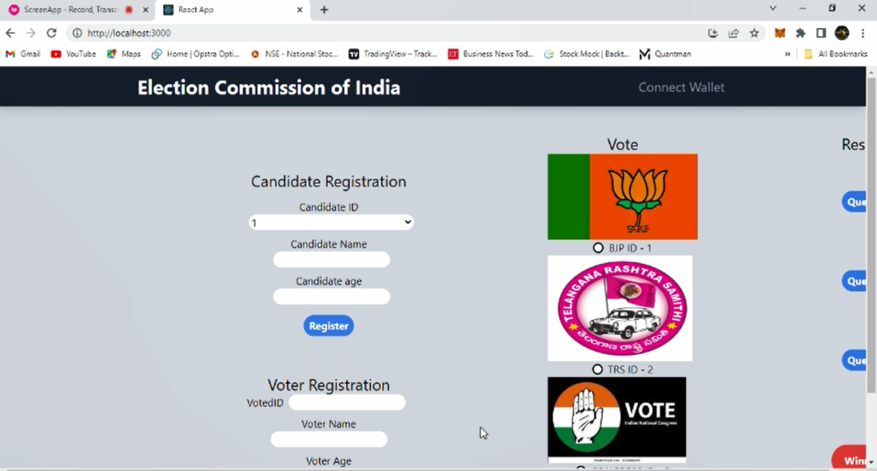

**Description of Screenshots**: For each screenshot provided, offer a description of what is depicted in the image. Explain the specific screen, user interface, or system functionality that is visible in the screenshot.

**User Perspective**: Ensure that the descriptions are written from a user's perspective, making it easy for non-technical stakeholders to understand and relate to the visuals.

**Sequence of Screens**: Arrange the screenshots in a logical order that tells a story or illustrates the flow of user interactions within the Electronic Voting System. This helps readers follow the process intuitively.

**9.2 Data Analysis and Findings:**

**Data Interpretation:** Analyze the data collected during the project, including user interactions, system performance metrics, and any other relevant data. Interpret this data to derive insights and conclusions.

**Conformance to Requirements:** Evaluate the project's performance and deliverables in the context of the established requirements and objectives. Determine whether the system meets its intended goals.

**Comparison to Targets**: Compare the actual project outcomes to the predefined targets, such as performance metrics, security standards, and user requirements. Assess whether the project successfully achieved its objectives.

**Key Findings**: Summarize the key findings from the project. These findings can include both positive outcomes, such as successful implementation of features, and areas for improvement.

**9.3 Lessons Learned:**

**Challenges Faced**: Discuss the challenges and obstacles encountered during the project's execution. These challenges could be technical, logistical, or related to team dynamics.

**Successes and Achievements**: Highlight the successes and achievements that were particularly noteworthy. These could include the successful implementation of complex features, adherence to project timelines, or the development of innovative solutions.

**Recommendations for Future Projects:** Based on the project's experiences and outcomes, provide recommendations for future projects, especially those in a similar domain. Share insights into what worked well and what could be done differently.

**9.4 Stakeholder Feedback:**

User Feedback: If available, present feedback from users, stakeholders, or any parties involved in testing the system. Include both positive feedback and constructive criticism.

Response to Feedback: Explain how the project team addressed user feedback and made improvements based on this input.

**9.5 Compliance and Regulatory Evaluation**:

Legal and Regulatory Compliance: Assess the Electronic Voting System's compliance with relevant legal and regulatory requirements, such as data privacy laws and election regulations.

Conformity to Standards: Confirm that the system adheres to industry standards and best practices, especially in terms of security and data integrity.

Recommendations for Compliance: If any non-compliance issues are identified, provide recommendations for addressing and rectifying these concerns.

This section serves as a comprehensive summary of the project's results, highlighting what was achieved, how it aligns with the project's objectives, and what was learned throughout the project's lifecycle. It also emphasizes the project's responsiveness to user feedback and its compliance with legal and regulatory standards. The results section provides valuable insights for stakeholders, project managers, and future project teams.

**10.ADVANTAGES & DISADVANTAGES**

The Advantages & Disadvantages section of the document for the Electronic Voting System project assesses the strengths and weaknesses of the system. This evaluation provides a balanced view of the system's capabilities and limitations. Here's an elaboration of the components of this section:

**10.1 Advantages:**

Security Enhancements: Explain how the Electronic Voting System improves the security of the voting process. Discuss features such as encryption, authentication mechanisms, and safeguards against fraud and cyber threats.

Transparency and Integrity: Highlight the advantages of the system in terms of ensuring transparent and tamper-proof elections. Discuss how the system maintains the integrity of the voting process.

Accessibility: Emphasize how the system enhances accessibility for voters, including those with disabilities, by providing accessible interfaces and options for remote voting.

Efficiency: Discuss how the system streamlines the voting process, reduces the risk of errors, and accelerates the tallying and reporting of election results.

Environmental Impact: If applicable, consider the advantages in terms of environmental sustainability. Electronic voting can reduce the use of paper and contribute to a greener election process.

User-Friendly Interfaces: Highlight user-friendly interfaces that make it easier for voters to cast their ballots, ensuring a positive user experience.

**10.2 Disadvantages:**

Technical Challenges: Discuss technical challenges that the system may face, such as potential software bugs, hardware failures, or issues related to internet connectivity.

Security Risks: Elaborate on the security risks and vulnerabilities that the system might be exposed to, including the possibility of hacking, data breaches, or insider threats.

Access Barriers: Mention any potential disadvantages related to accessibility, such as barriers for users who are not tech-savvy or who lack access to the necessary technology.

Maintenance and Costs: Consider the costs associated with maintaining and updating the system. Also, discuss potential budgetary challenges that may arise.

Regulatory Compliance: Highlight the need to comply with complex and evolving regulations and how non-compliance can pose a disadvantage.

Trust and Acceptance: Discuss potential trust issues and public acceptance challenges, as some voters may be skeptical about electronic voting due to concerns about security and transparency.

**10.3 Mitigation Strategies:**

Provide strategies and recommendations for mitigating the identified disadvantages. Explain how the project team plans to address these challenges and minimize their impact.

Discuss the importance of ongoing monitoring, regular software updates, and security audits to mitigate risks.

By providing a balanced assessment of the advantages and disadvantages of the Electronic Voting System, this section offers a clear understanding of the system's potential benefits and the challenges it may encounter. This helps project stakeholders and decision-makers make informed choices and prepare for possible issues while capitalizing on the system's strengths.

**11.CONCLUSION**

The Blockchain Electronic Voting System project is a remarkable endeavor that marks a pivotal step forward in the realm of democratic processes. In an age where technology is ubiquitous, the demand for secure, transparent, and accessible voting systems has never been more pressing. This project addresses the critical challenges that have plagued traditional voting methods, offering the potential to reshape the way elections are conducted.

The project's inception involved an in-depth literature survey, meticulously uncovering the shortcomings, vulnerabilities, and problems prevalent in existing electronic voting systems. These findings provided the framework for a user-centric, empathetic approach to ideation, ultimately yielding an innovative solution designed to alleviate these identified issues. Rigorous requirement analysis and project design led to the development of a technical architecture that prioritizes security, scalability, and user-friendliness.

The project's extensive planning and scheduling efforts laid the groundwork for the successful coding and solutioning phase. The outcome is a system replete with feature-rich implementations, intuitive user interfaces, and robust database schemas. Rigorous performance testing affirmed the system's reliability, efficiency, and adherence to predefined metrics.

This Blockchain Electronic Voting System offers numerous advantages, including enhanced security measures, transparent and tamper-proof elections, improved accessibility, and streamlined voting processes. Nevertheless, the project does not shy away from acknowledging the existence of challenges and disadvantages, such as potential technical issues, security risks, and trust barriers. Importantly, it provides strategies and recommendations to mitigate these concerns.

In conclusion, the Blockchain Electronic Voting System project represents a testament to innovation, unwavering dedication, and a commitment to upholding democratic values. It possesses the transformative potential to fundamentally reshape the way societies engage in the electoral process, fostering trust, inclusivity, and efficiency. The project's impact transcends mere technological advancements, touching on issues of societal trust, participation, and sustainability.

As the project concludes, it casts its gaze toward the future. It envisions a world where continuous improvement and expansion promise even more robust, secure, and accessible electronic voting systems. This project is a powerful reminder that, in an ever-evolving world, technology can serve as a cornerstone for safeguarding the foundations of democracy. The Blockchain Electronic Voting System project stands as a beacon of progress and extends an invitation for further innovation in the service of democratic values.

**12.FUTURE SCOPE**

The Blockchain Electronic Voting System project lays a strong foundation for secure, transparent, and accessible elections. As technology continues to advance, there are numerous opportunities for future development and expansion of this system. Here's a detailed elaboration of the future scope for this project:

**12.1 Enhanced Security Features:**

Future iterations of the system can focus on even more robust security measures. This might include the implementation of advanced cryptographic techniques, multi-factor authentication, and blockchain enhancements. Ensuring that the system remains impervious to cyber threats is an ongoing process, and regular security audits and updates are essential.

**12.2 Integration with Identity Verification Systems:**

To further enhance security and reduce the risk of fraudulent voting, the system can be integrated with identity verification solutions. Advanced biometric verification, government-issued digital identities, or secure authentication methods could be explored to ensure that each voter is who they claim to be.

**12.3 Accessibility and Inclusivity:**

Continued efforts to improve accessibility can include features for voters with disabilities, support for multiple languages, and user-friendly interfaces for people of all ages and technological proficiencies. The system can also be adapted for remote or mobile voting, making it even more convenient for voters.

**12.4 Scalability for Large-Scale Elections:**

The system's architecture should be designed to scale seamlessly for elections of varying sizes, from local elections to nationwide or even international ones. Load balancing, cloud-based solutions, and adaptive resource allocation can be implemented to accommodate the increasing number of voters.

**12.5 Mobile Voting Applications:**

The development of secure mobile voting applications can provide voters with the flexibility to cast their ballots from their smartphones. These applications would need to meet rigorous security standards while offering a convenient and user-friendly experience.11.11.

**12.6 Blockchain Innovations:**

As blockchain technology evolves, the system can leverage the latest advancements, such as faster consensus algorithms, reduced energy consumption, and improved interoperability with other blockchains. These advancements can enhance the transparency and reliability of the system.

**12.7 Continuous Regulatory Compliance:**

With evolving regulations and legal frameworks surrounding elections, the system must stay updated and compliant. Staying abreast of changes in data privacy laws, election regulations, and cybersecurity standards is crucial.

**12.8 User Feedback Integration:**

Collecting feedback from users and election stakeholders can be an ongoing process. Regular surveys and user feedback loops will allow for continuous improvement and the identification of pain points or areas for enhancement.

**12.9 Public Awareness and Trust-Building:**

Promoting public awareness and trust in the system is an ongoing effort. Educational campaigns, transparency initiatives, and engagement with the public can help build trust and encourage participation.

**12.10 International Adoption and Collaboration:**

The system's success can serve as a model for other countries and regions. Collaborating with international organizations and governments can lead to the adoption of similar systems on a global scale, promoting democratic practices and secure elections worldwide.

In conclusion, the future scope for the Blockchain Electronic Voting System project is vast and promising. The project's success thus far demonstrates the potential for secure, transparent, and accessible elections. By focusing on security, accessibility, scalability, and compliance, this system can continue to evolve and contribute to the advancement of democratic processes on a global scale.

**13. APPENDIX**

**SOURCE CODE:**

import "./App.css";

import Home from "./pages/Home";

import { Navbar } from "./components/Navbar";

function App() {

return (

<div className="App">

<Navbar />

<Home />

</div>

);

}

export default App;

.App {

text-align: center;

}

.App-logo {

height: 40vmin;

pointer-events: none;

}

@media (prefers-reduced-motion: no-preference) {

.App-logo {

animation: App-logo-spin infinite 20s linear;

}

}

.App-header {

background-color: #282c34;

min-height: 100vh;

display: flex;

flex-direction: column;

align-items: center;

justify-content: center;

font-size: calc(10px + 2vmin);

color: white;

}

.App-link {

color: #61dafb;

}

@keyframes App-logo-spin {

from {

transform: rotate(0deg);

}

to {

transform: rotate(360deg);

  }

}

import React from 'react';

import ReactDOM from 'react-dom/client';

import './index.css';

import App from './App';

import reportWebVitals from './reportWebVitals';

const root = ReactDOM.createRoot(document.getElementById('root'));

root.render(

<React.StrictMode>

<App />

</React.StrictMode>

);

// If you want to start measuring performance in your app, pass a function

// to log results (for example: reportWebVitals(console.log))

// or send to an analytics endpoint. Learn more: https://bit.ly/CRA-vitals

reportWebVitals();

body {

margin: 0;

font-family: -apple-system, BlinkMacSystemFont, 'Segoe UI', 'Roboto', 'Oxygen',

'Ubuntu', 'Cantarell', 'Fira Sans', 'Droid Sans', 'Helvetica Neue',

sans-serif;

-webkit-font-smoothing: antialiased;

-moz-osx-font-smoothing: grayscale;

background-color: #d6dbe4;

}

code {

font-family: source-code-pro, Menlo, Monaco, Consolas, 'Courier New',

monospace;

}

@tailwind base;

@tailwind components;

@tailwind utilities;

import { render, screen } from '@testing-library/react';

import App from './App';

test('renders learn react link', () => {

render(<App />);

const linkElement = screen.getByText(/learn react/i);

expect(linkElement).toBeInTheDocument();

});

const reportWebVitals = onPerfEntry => {

if (onPerfEntry&&onPerfEntryinstanceof Function) {

import('web-vitals').then(({ getCLS, getFID, getFCP, getLCP, getTTFB }) => {

getCLS(onPerfEntry);

getFID(onPerfEntry);

getFCP(onPerfEntry);

getLCP(onPerfEntry);

getTTFB(onPerfEntry);

});

}

};

export default reportWebVitals;

// jest-dom adds custom jest matchers for asserting on DOM nodes.

// allows you to do things like:

// expect(element).toHaveTextContent(/react/i)

// learn more: https://github.com/testing-library/jest-dom

import '@testing-library/jest-dom';

// SPDX-License-Identifier: MIT

pragma solidity ^0.8.0;

contract VoteSystem{

address public owner;

constructor(){

owner= msg.sender;

}

struct candidate {

uintvoterId;

string name;

uint age;

uintvoteCount;

}

mapping (uint => candidate) candidateMap;

struct voters {

uintvoterId;

string name;

uint age;

bool votingState;

}

mapping (uint => voters) votersMap;

mapping (uint=>bool) registeredVoter;

modifier checkVoterVoted(uint _votersVoterId){

require (votersMap[_votersVoterId].votingState == false);

_;

}

modifier checkRegisteredVoter(uint _votersVoterId){

require(registeredVoter[_votersVoterId]==true, "Voter is not Registered");

_;

}

uint[] voterIdlist;

uint[] candidateIdList;

function enrollCandidate(uint _voterId,string memory _name,uint _age ) public {

require (_age >= 25);

require (candidateMap[_voterId].voterId != _voterId);

candidateMap[_voterId].voterId = _voterId;

candidateMap[_voterId].name = _name;

candidateMap[_voterId].age = _age;

candidateIdList.push(_voterId);

}

function enrollVoter(uint _voterId,string memory _name,uint _age) public returns(bool){

require (_age >= 18);

require (votersMap[_voterId].voterId != _voterId);

votersMap[_voterId].voterId = _voterId;

votersMap[_voterId].name = _name;

votersMap[_voterId].age = _age;

voterIdlist.push(_voterId);

return registeredVoter[_voterId]=true;

}

function getCandidateDetails(uint _voterId) view public returns(uint,stringmemory,uint,uint) {

return (candidateMap[_voterId].voterId,candidateMap[_voterId].name,candidateMap[_voterId].age,candidateMap[_voterId].voteCount);

}

function getVoterDetails(uint _voterId) view public returns (uint,stringmemory,uint,bool){

return (votersMap[_voterId].voterId,votersMap[_voterId].name,votersMap[_voterId].age,votersMap[_voterId].votingState);

}

function vote(uint _candidateVoterId,uint _votersVoterId) public checkVoterVoted(_votersVoterId) checkRegisteredVoter(_votersVoterId) {

candidateMap[_candidateVoterId].voteCount += 1;

votersMap[_votersVoterId].votingState = true;

}

function getVotecountOf(uint _voterId) view public returns(uint){

require(msg.sender== owner, "Only owner is allowed to Check Results");

return candidateMap[_voterId].voteCount;

}

function getVoterList() view public returns (uint[] memory){

return voterIdlist;

}

function getCandidateList() view public returns(uint[] memory){

return candidateIdList;

 }

}

import { ethers } from "ethers";

import abi from "./voting.json";

export const contractAddress = "0xE6eF3733c6276e99385391064764Dd493814C36F";

export const provider = new ethers.providers.Web3Provider(window.ethereum);

export const signer = provider.getSigner();

export const votingContract = new ethers.Contract(contractAddress, abi, signer);

[

{

"inputs": [],

"stateMutability": "nonpayable",

"type": "constructor"

},

{

"inputs": [

{

"internalType": "uint256",

"name": "_voterId",

"type": "uint256"

},

{

"internalType": "string",

"name": "_name",

"type": "string"

},

{

"internalType": "uint256",

"name": "_age",

"type": "uint256"

}

],

"name": "enrollCandidate",

"outputs": [],

"stateMutability": "nonpayable",

"type": "function"

},

{

"inputs": [

{

"internalType": "uint256",

"name": "_voterId",

"type": "uint256"

},

{

"internalType": "string",

"name": "_name",

"type": "string"

},

{

"internalType": "uint256",

"name": "_age",

"type": "uint256"

}

],

"name": "enrollVoter",

"outputs": [

{

"internalType": "bool",

"name": "",

"type": "bool"

}

],

"stateMutability": "nonpayable",

"type": "function"

},

{

"inputs": [

{

"internalType": "uint256",

"name": "_voterId",

"type": "uint256"

}

],

"name": "getCandidateDetails",

"outputs": [

{

"internalType": "uint256",

"name": "",

"type": "uint256"

},

{

"internalType": "string",

"name": "",

"type": "string"

},

{

"internalType": "uint256",

"name": "",

"type": "uint256"

},

{

"internalType": "uint256",

"name": "",

"type": "uint256"

}

],

"stateMutability": "view",

"type": "function"

},

{

"inputs": [],

"name": "getCandidateList",

"outputs": [

{

"internalType": "uint256[]",

"name": "",

"type": "uint256[]"

}

],

"stateMutability": "view",

"type": "function"

},

{

"inputs": [

{

"internalType": "uint256",

"name": "_voterId",

"type": "uint256"

}

],

"name": "getVotecountOf",

"outputs": [

{

"internalType": "uint256",

"name": "",

"type": "uint256"

}

],

"stateMutability": "view",

"type": "function"

},

{

"inputs": [

{

"internalType": "uint256",

"name": "_voterId",

"type": "uint256"

}

],

"name": "getVoterDetails",

"outputs": [

{

"internalType": "uint256",

"name": "",

"type": "uint256"

},

{

"internalType": "string",

"name": "",

"type": "string"

},

{

"internalType": "uint256",

"name": "",

"type": "uint256"

},

{

"internalType": "bool",

"name": "",

"type": "bool"

}

],

"stateMutability": "view",

"type": "function"

},

{

"inputs": [],

"name": "getVoterList",

"outputs": [

{

"internalType": "uint256[]",

"name": "",

"type": "uint256[]"

}

],

"stateMutability": "view",

"type": "function"

},

{

"inputs": [],

"name": "owner",

"outputs": [

{

"internalType": "address",

"name": "",

"type": "address"

}

],

"stateMutability": "view",

"type": "function"

},

{

"inputs": [

{

"internalType": "uint256",

"name": "_candidateVoterId",

"type": "uint256"

},

{

"internalType": "uint256",

"name": "_votersVoterId",

"type": "uint256"

}

],

"name": "vote",

"outputs": [],

"stateMutability": "nonpayable",

"type": "function"

}

]

import React from "react";

import Voting from "../components/Voting";

function Home() {

return <Voting />;

}

export default Home;

import { useState } from "react";

export const Navbar = () => {

const [CurrentAccount, setCurrentAccount] = useState("");

const walletConnect = async () => {

if (!window.ethereum) {

return alert("please install metamask");

}

const addr = await window.ethereum.request({ method: "eth_requestAccounts" });

setCurrentAccount(addr[0]);

};

return (

<nav className="bg-gray-900 shadow-lg">

<div className="container mx-auto">

<div className="sm:flex justify-around">

<a href="/" className="text-white text-3xl font-bold p-3">

Election Commission of India

</a>

<ulclassName="text-gray-400 sm:self-center text-xl border-t sm:border-none">

<li className="sm:inline-block">

{!CurrentAccount ? (

<button onClick={walletConnect} className="p-3 hover:text-white">

Connect Wallet

</button>

) : (

<p>{CurrentAccount}</p>

)}

</li>

</ul>

</div>

</div>

</nav>

);

};

import React, { useState } from "react";

import { votingContract } from "../utils/constants";

function Voting() {

const [CandidateName, setCandidateName] = useState("");

const [CandidateAge, setCandidateAge] = useState("");

const [CandidateID, setCandidateID] = useState("");

const [VoterID, setVoterID] = useState("");

const [VoterName, setVoterName] = useState("");

const [VoterAge, setVoterAge] = useState("");

const [VoterVoteID, setVoterVoteID] = useState("");

const [PartyID, setPartyID] = useState("");

const [VoteCount1, setVoteCount1] = useState("");

const [VoteCount2, setVoteCount2] = useState("");

const [VoteCount3, setVoteCount3] = useState("");

const [HighestCount, setHighestCount] = useState("");

const handleCandidatename = (e) => {

setCandidateName(e.target.value);

};

const handleCandidateAge = (e) => {

const value = e.target.value.replace(/\D/g, "");

setCandidateAge(Number(value));

};

const handleCandidateID = async (e) => {

const value = e.target.value.replace(/\D/g, "");

setCandidateID(Number(value));

};

const handleCandidateRegistration = async (e) => {

e.preventDefault();

const enrollCanddidateTx = await votingContract.enrollCandidate(CandidateID, CandidateName, CandidateAge);

await enrollCanddidateTx.wait();

console.log(enrollCanddidateTx);

alert(enrollCanddidateTx.hash);

};

const handleVoterID = async (e) => {

const value = e.target.value.replace(/\D/g, "");

setVoterID(Number(value));

};

const handleVoterName = (e) => {

setVoterName(e.target.value);

};

const handleVoterAge = async (e) => {

const value = e.target.value.replace(/\D/g, "");

setVoterAge(Number(value));

};

const handleVoterRegistration = async (e) => {

e.preventDefault();

const enrollVoterTx = await votingContract.enrollVoter(VoterID, VoterName, VoterAge);

await enrollVoterTx.wait();

console.log(enrollVoterTx);

alert(enrollVoterTx.hash);

};

const handlePartyID = async (e) => {

setPartyID(Number(e.target.value));

};

const handleVoterVoteID = async (e) => {

const value = e.target.value.replace(/\D/g, "");

setVoterVoteID(Number(value));

};

const handleVote = async (e) => {

e.preventDefault();

const voteTx = await votingContract.vote(PartyID, VoterVoteID);

await voteTx.wait();

console.log(voteTx);

alert(voteTx.hash);

};

const handleQuery1 = async (e) => {

let vote = Number(e.target.id);

const voteCountTx = await votingContract.getVotecountOf(vote);

setVoteCount1(voteCountTx.toString());

};

const handleQuery2 = async (e) => {

let vote = Number(e.target.id);

const voteCountTx = await votingContract.getVotecountOf(vote);

setVoteCount2(voteCountTx.toString());

};

const handleQuery3 = async (e) => {

let vote = Number(e.target.id);

const voteCountTx = await votingContract.getVotecountOf(vote);

setVoteCount3(voteCountTx.toString());

};

const handleResult = async () => {

let number1 = await votingContract.getVotecountOf(1);

let number2 = await votingContract.getVotecountOf(2);

let number3 = await votingContract.getVotecountOf(3);

let num1 = number1.toString();

let num2 = number2.toString();

let num3 = number3.toString();

if (num1 > num2 && num1 > num3) {

setHighestCount("BJP");

} else if (num2 > num1 && num2 > num3) {

setHighestCount("TRS");

} else if (num3 > num1 && num3 > num2) {

setHighestCount("Congress");

} else {

setHighestCount("");

}

};

return (

<div>

<div className="flex flex-row space-x-52 mt-10 ml-96">

<div>

<div className="mt-14 ">

<h3 className="text-2xl">Candidate Registration</h3>

<form onSubmit={handleCandidateRegistration}>

<div className="form-group mb-6">

<div className="mt-3"></div>

<div className="space-y-2">

<div>

<label>

Candidate ID

<select className="w-64 ml-2 rounded-full text-slate-900" value={CandidateID} onChange={handleCandidateID}>

<option name="BJP">1</option>

<option name="TRS">2</option>

<option name="CONGRESS">3</option>

</select>

</label>

</div>

<div>

<label>

Candidate Name

<span>

<input className="ml-2 rounded-full text-slate-900" value={CandidateName} onChange={handleCandidatename} />

</span>

</label>

</div>

<div>

<label>

Candidate age

<span>

<input className="ml-2 rounded-full text-slate-900" value={CandidateAge} onChange={handleCandidateAge} />

</span>

</label>

</div>

</div>

<input className="bg-blue-500 hover:bg-blue-900 text-white font-bold py-1 px-2 rounded-full mt-4" type="submit" value="Register" />

</div>

</form>

</div>

<div className="mt-14">

<h3 className="text-2xl">Voter Registration</h3>

<form onSubmit={handleVoterRegistration}>

<div>

<label>

VotedID

<span className="ml-2 mr-2 ">

<input className="rounded-full text-slate-900" value={VoterID} onChange={handleVoterID} />

</span>

</label>

</div>

<div className="mt-2">

<label>

Voter Name

<span className="ml-2 mr-2 ">

<input className="rounded-full text-slate-900" value={VoterName} onChange={handleVoterName} />

</span>

</label>

</div>

<div className="mt-2">

<label>

Voter Age

<span className="ml-2 mr-2 ">

<input className="rounded-full text-slate-900" value={VoterAge} onChange={handleVoterAge} />

</span>

</label>

</div>

<button className="bg-blue-500 hover:bg-blue-900 text-white font-bold py-1 px-2 rounded-full mt-2">Register</button>

</form>

</div>

</div>

<div>

<form onSubmit={handleVote}>

<p className="text-2xl">Vote</p>

<div>

<div>

<img

className="max-w-sm max-h-40 full-auto"

src="https://encrypted-tbn0.gstatic.com/images?q=tbn:ANd9GcT1PeilVpA3QSlwxU5Z34Oc1Y-x_Idy3bU8nLrhTLtUhQ&s"

alt="BJP"

/>

</div>

<div>

<input

className="form-check-input appearance-none rounded-full h-4 w-4 border border-black border-x-2 border-y-2 bg-white checked:bg-blue-600 checked:border-blackfocus:outline-none transition duration-200 mt-1 align-top bg-no-repeat bg-center bg-contain mr-2 cursor-pointer"

type="radio"

name="flexRadioDefault"

value="1"

onChange={handlePartyID}

/>

<label className="form-check-label inline-block text-gray-800" htmlFor="flexRadioDefault1">

BJP ID - 1

</label>

</div>

</div>

<div>

<div>

<img

className="w-56 max-h-40 full-auto"

src="https://4.bp.blogspot.com/-usfE8G6o_wY/WsjahdsdZGI/AAAAAAAAWBI/dexdE3O-Jt0XN0v2GvdWswfDww8HuVbAQCLcBGAs/s1600/trs03%2Bcopy.jpg"

alt="TRS"

/>

</div>

<div>

<input

className="form-check-input appearance-none rounded-full h-4 w-4 border border-black border-x-2 border-y-2 bg-white checked:bg-blue-600 checked:border-blackfocus:outline-none transition duration-200 mt-1 align-top bg-no-repeat bg-center bg-contain mr-2 cursor-pointer"

type="radio"

name="flexRadioDefault"

value="2"

onChange={handlePartyID}

/>

<label className="form-check-label inline-block text-gray-800" htmlFor="flexRadioDefault1">

TRS ID - 2

</label>

</div>

</div>

<div>

<div>

<img

className="max-w-sm max-h-40 full-auto"

src="https://encrypted-tbn0.gstatic.com/images?q=tbn:ANd9GcRTLtqW8T4TEv-Ni-3NbGT28sFKUQOkoUEnOCryW3ZGuA&s"

alt="CONGRESS"

/>

</div>

<div>

<input

className="form-check-input appearance-none rounded-full h-4 w-4 border border-black border-x-2 border-y-2 bg-white checked:bg-blue-600 checked:border-blackfocus:outline-none transition duration-200 mt-1 align-top bg-no-repeat bg-center bg-contain mr-2 cursor-pointer"

type="radio"

name="flexRadioDefault"

value="3"

onChange={handlePartyID}

/>

<label className="form-check-label inline-block text-gray-800" htmlFor="flexRadioDefault1">

CONGRESS ID - 3

</label>

</div>

</div>

<div className="mt-5">

<label>

VotedID

<span className="ml-2 mr-2 ">

<input className="rounded-full w-20 text-slate-900" value={VoterVoteID} onChange={handleVoterVoteID} />

</span>

</label>

</div>

<input className="bg-red-500 hover:bg-blue-900 text-white font-bold py-3 px-16 rounded-full mt-4" type="submit" value="Vote" />

</form>

</div>

{/* =>>>>>>>............................................................................. */}

<div>

<div className="">

<p className="text-2xl">Result</p>

<div className="mt-12"></div>

<button onClick={handleQuery1} id="1" className="bg-blue-500 hover:bg-blue-900 text-white font-bold py-1 px-2 rounded-full mt-2">

Query

</button>

<p>{VoteCount1}</p>

</div>

<div className="mt-20">

<div></div>

<button onClick={handleQuery2} id="2" className="bg-blue-500 hover:bg-blue-900 text-white font-bold py-1 px-2 rounded-full mt-2">

Query

</button>

<p>{VoteCount2}</p>

</div>

<div className="mt-20">

<button onClick={handleQuery3} id="3" className="bg-blue-500 hover:bg-blue-900 text-white font-bold py-1 px-2 rounded-full mt-2">

Query

</button>

<p>{VoteCount3}</p>

</div>

<div className="mt-28">

<button onClick={handleResult} className="bg-red-500 hover:bg-blue-900 text-white font-bold py-3 px-5 rounded-full ">

Winner

</button>

<p className="text-3xl">{HighestCount}</p>

</div>

</div>

{/* =>>>>>>>........................................................................ */}

</div>

</div>

);

}

export default Voting;